OS & SP
Name : M Ramya Sree Roll No : 2520030094
Practical – 07

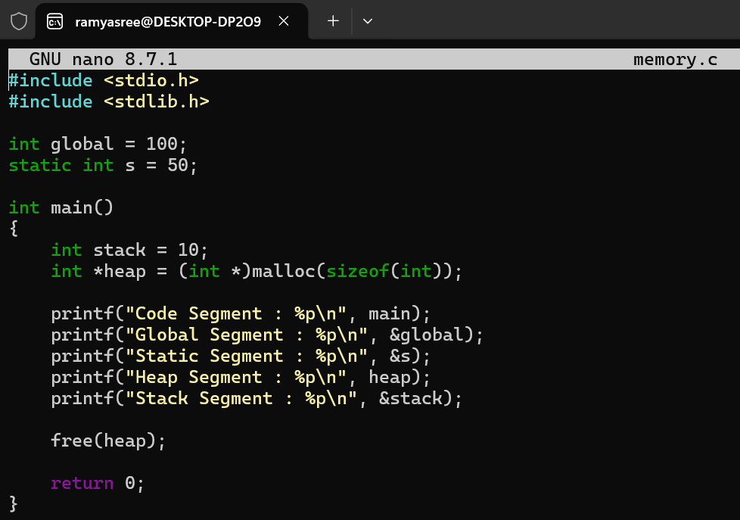
OUTPUT :
